Homework 1

Joyce LJ Woznica

# Introduction

With a deep interest in horses, investigating different approaches and writing styles when composing literature about these majestic animals was a simple choice for this assignment. Two texts were found that allowed for comparisons from the writing of two different women who composed their books almost 75 years apart. These books both emphasized the horse’s adventures and hardships encountered over a single lifetime.

# Texts

The first text was *Black Beauty* written by Anna Sewell and published in 1877. Sewell was born into a devout Quaker family in Great Yarmouth, Norfolk England. Sewell was home schooled for financial reasons. This same lack of money led Sewell to spend time in Buxton with her maternal grandparents. Sewell spent most of her life using crutches because of an ankle injury in her teens. *Black Beauty* was written while she was in declining health later in her life. She died at the age of 58 shortly after the publishing of *Black Beauty*.

The second text is *King of the Wind* by Marguerite Henry published in 1949. Henry is well known for her books about horses. She was born in Milwaukee, Wisconsin. Much like Sewell, Henry was bedridden until age twelve and could not attend school. She had many pets that were said to inspire her stories. Most know Henry for her book *Misty of Chincoteague* and *Justin Morgan Had a Horse*.

## Questions

I felt these two children’s books although similar subjects would provide both similarities and significant contrasts. Not only did the women write these books almost 75 years apart, but they come from different parts of the world which might influence their writing style. Moreover, one is from the horse’s perspective while the other is from his master’s point of view.

How are the writing styles of *Black Beauty* and *King of the Wind* different and similar? What is unique about how the two authors approach the story of a horse’s life?

## Corpora Sources

These books were obtained from the following sources:

* *King of the Wind:*  <https://archive.org/stream/KingOfTheWind/kingofwind_djvu.txt> as *kingofthewind.txt*
* *Black Beauty:*  <http://www.gutenberg.org/files/271/271-0.txt> as *blackbeauty.txt*

Each was downloaded in *.txt* format. In order to read the text files for use in this exercise, the last 365 lines of *blackbeauty.*txt file were removed. These lines consisted of the Gutenberg project information and licensing. This step was done manually. The text was renamed as *blackbeautyF.txt*. In addition, the first 113 tokens were removed from the same text file. These were the Gutenberg introduction words. This latter removal was done programmatically in the text. No further preprocessing was required on the either corpus.

## Corpora Processing

### Package Loading

The first step was to load the required packages in python in preparation for analysis of bigrams. As shown in the following figure, additional packages were loaded so that visualizations could be done on the data returned for additional analysis of the results.

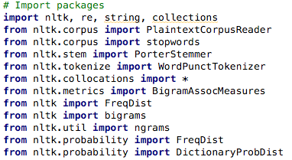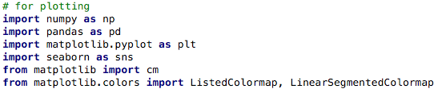

Figure Importing of Packages

### Text Preprocessing

After the packages were loaded, the two text files representing the books selected were read and then cleaned for analysis. The first step was to remove any “new line” (or “\n”) characters from the text and then tokenize the text into individual chunks or tokens. As mentioned, the first 114 tokens from *Black Beauty* were removed.

In reviewing these tokens, additional cleanup was required:

* Removing newlines – using the replace function was used to replace all new line characters with a space.
* Lowercasing – all words were converted to lower case so that capitalization would not limit the gathering of the same words together.
* Punctuation and non-alpha character removal – removing of commas, question marks and other punctuation was removed so words could be the focus of the analysis. In addition, numbers were removed for the same reason.
* Removal of stop words – initial review showed a high frequency of words like “it”, “but”, “the” and other stop words. The default *nltk.stopwords* were used with the addition of the following:
  + could, would, one, might, ‘s, ‘d, n’t, ca, ‘ll, ‘t, ‘m, ‘re, ‘ve

The additional words were added after review of the tokens revealed split contractions and additional words that had little to no meaning in the text.

* No additional processing of the text was done, but the following were considered:
  + There were several 2 character words like “us”, “ye”, “go” in the top 50 words, but it was determined that these may provide more meaning to sentences and bigrams and trigrams so they were not removed.
  + No stemming was done although stemming for “horse” for words like “horses” would have been appropriate, stemming for words like “horseman” or “horsemanship” would have changed the meaning of the words, so stemming was not done.

As this approach was taken, the decrease in the number of tokens was maintained in a dictionary for each corpus. These dictionaries are shown below:

﻿***Black Beauty***: {'Initial': 304579, 'Tokens': 70563, 'NoPunc': 60551, 'NoStop': 25804}

***King of the Wind*:** ﻿{'Initial': 184464, 'Tokens': 39462, 'NoPunc': 33656, 'NoStop': 16868}

This information represents the following:

* Initial Corpus: ‘Initial’ – 304,579 for *Black Beauty* and 184,464 for *King of the Wind*
* Tokenized Corpus: ‘Tokens’ – 70,563 for *Black Beauty* and 39,462 for *King of the Wind*
* Tokens without Punctuation: ‘NoPunc’ – 60,551 for *Black Beauty* and 33,656 for *King of the Wind*
* Tokens without Stop Words: ‘NoStop’ – 25,804 for *Black Beauty* and 16,868 for *King of the Wind*

It is remarkable how much of the text in a corpora of this size is “filler” or inconsequential words.

# Corpora Comparison

The following were reviewed for each corpus:

* Top 50 words by frequency (normalized)
* Top 50 bigrams by frequency
* Top 50 trigrams by frequency
* Top 50 bigrams by Pointwise Mutual Information (PMI) scores
* Top 50 trigrams by PMI

Each is covered in more detail in this section.

## Top 50 Words by Frequency

Initially, the top 50 words from each corpus were found and then the frequency number was normalized by the total number of words used in that corpus. This was done using the *nltk* package and the use of *nltk.FreqDist* function.

The following figure shows the top 50 words by frequency including the normalized frequency for each corpus selected.

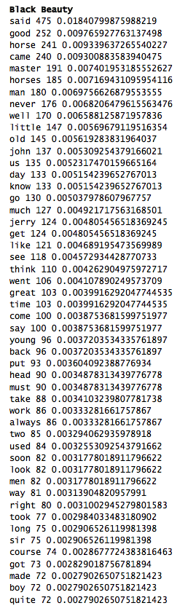 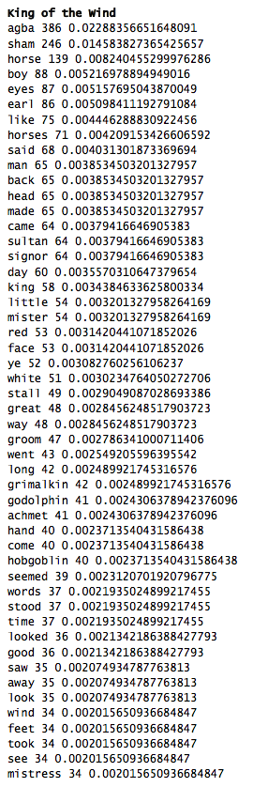

Figure Top 50 Words (Normalized) by Frequency by Corpus

There were a significant number of words in the top 50 that were similar in the books. As expected, “horse” and “horses” were high in the numbers with similar normalized frequencies. Also was terms referring to “man”, “boy” and “master” indicating the similarities of the books discussing the relationship between horses and their human partner. It is interesting that the use of the word “great” appears with similar frequency in both books.

It is also noticeable that the words used in *King of the Wind* are very typical of Arabia where the story begins with words like “sultan”, “agba”, “sham” as well as “godolphin”. Agba is the name of the boy who bonds with Sham who is the horse in the story. Godolphin is the name of the Earl that puts Sham to work in the story. However, these words are very typical of the geographical area of the book.

To assist in reviewing this information, the following visualizations were created to gain a better understanding of the top words.

Figure Graphical Representation Top 50 Words (Normalized) by Frequency for *Black Beauty*

Figure Graphical Representation Top 50 Words (Normalized) by Frequency for *King of the Wind*

## Top 50 Bigrams by Frequency

The next area of comparison was looking at the top 50 bigrams of each corpus. This was done using the *BigramCollocationFinder* that is part of the *nltk* package. The resulting bigrams and scores are represented in the following figure by corpus.

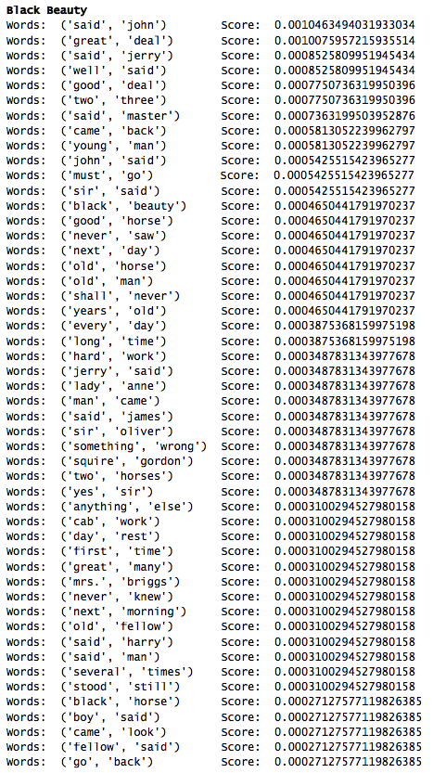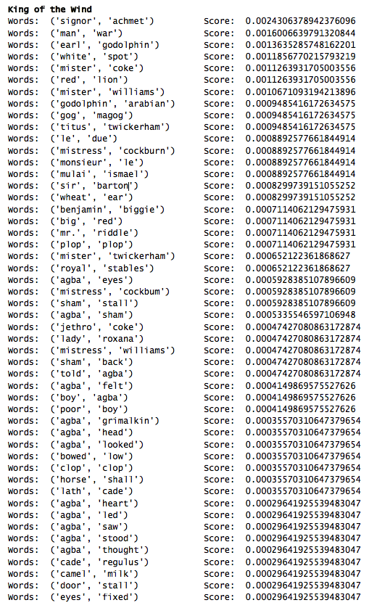

Figure Top 50 Bigrams by Score by Corpus

As shown here, the bigrams are very different by corpus. In *Black Beauty*, the words are very typical of older English style writing with things like “said jerry” or “said harry”. As noted, this text shows the life of a horse from the perspective of the horse. This is clear in the bigrams with combinations like “said master”, “boy said” or “man came”. You also notice that there is some information about tasks in the horse’s life with combinations like “hard work” and “day rest”.

Alternatively, the bigrams from *King of the Wind*, the combinations are more about the titles of individuals with words like “mister williams”, “earl godolphin” and “mistress cockburn”. You can also see some words very focused on Agba and his actions such as “agba looked”, “agba head”, “agba saw”. In addition, there are some actions like “bowed low” and “agba stood” along with feeling about Agba like “poor boy”.

As with the top 50 words, a visualization was completed for the top 50 bigrams by score as shown in the following two figures.

Figure Graphical Representation Top 50 Bigrams by Score for *Black Beauty*

Figure Graphical Representation Top 50 Bigrams by Score for *King of the Wind*

## Top 50 Trigrams by Frequency

To provide additional insight, the top 50 trigrams of each corpus were extracted. This was done using the *TrigramCollocationFinder* that is part of the *nltk* package. Setting the *frequency_*filter at 3, the resulting trigrams and scores are represented in the following figure by corpus.

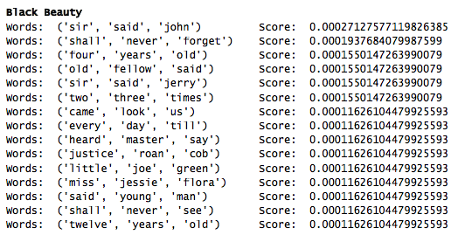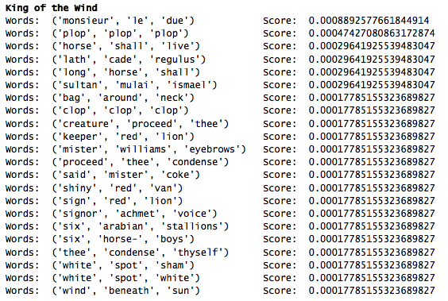

Figure Top Trigrams by Score by Corpus – Frequency Filter of 3

Although the top 50 trigrams were requested, the frequency filter of three (3) reduced that number to only 15 trigrams for *Black Beauty* and only 22 for *King of the Wind*. However, decreasing the frequency filter to two (2) increased the results significantly as shown in the following figure.

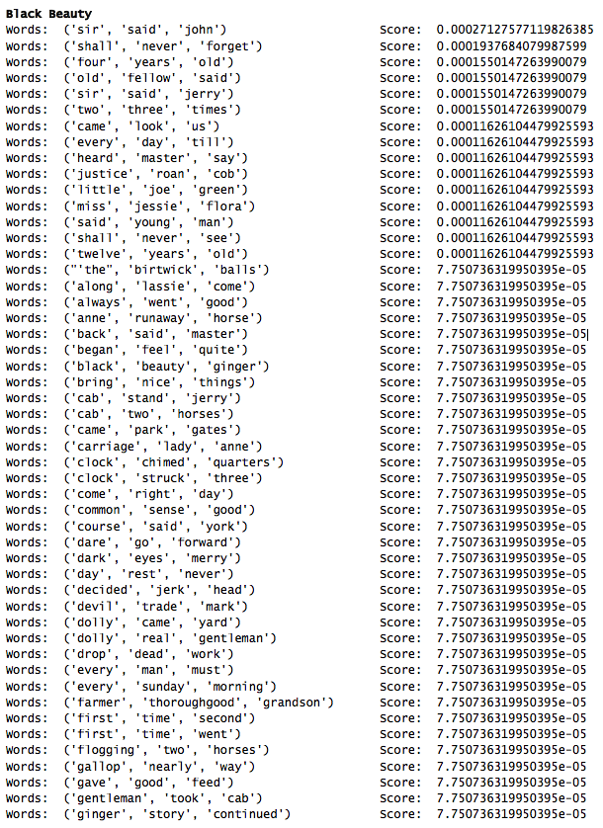

Figure Top 50 Trigrams by Score for *Black Beauty*  – Frequency Filter of 2

As seen in the preceding figure, using a frequency filter of two (2) provides much more details on the writing style of Anna Sewell. Word appearances like “along lassie come”, “clocked chimed quarters” and “shall never forget” are very English words and tend to show the old English style of *Black* Beauty as a novel. It is also more apparent that the story is different when taken from the perspective of the horse instead of his/her partner with words like “heard master say” and “gave good feed”. It also becomes clear that there were hardships in Beauty’s life with trigrams like “drop dead work” and “flogging two horses”. The style remains more formal as one would expect from a book written in England during the 19th century.

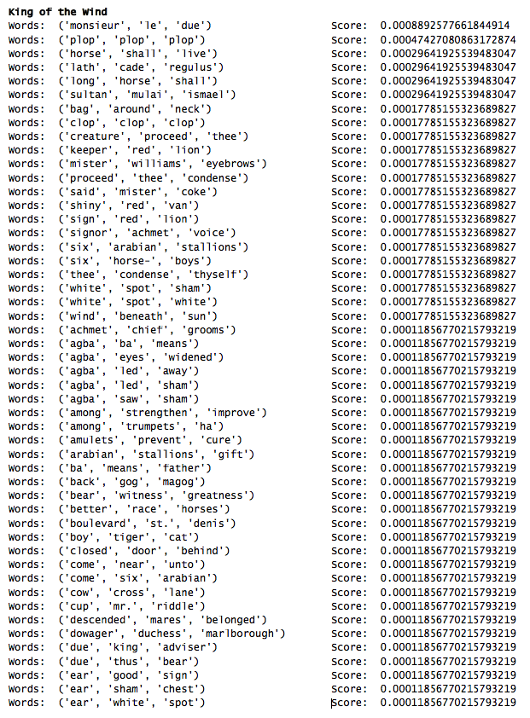

Figure Top 50 Trigrams by Score for *King of the Wind*  – Frequency Filter of 2

The trigrams for *King of the Wind* indicate a more ornate writing style despite the book being written near 1950 in America. One would have expected the book from England in the 19th century would have had a more flowery language, but it remains more formal. There is a significant emphasis on capturing the sounds as well as the surroundings in *King of the Wind* with words like “shiny red van”, “agba eyes widened” , “clop clop clop” and “wind beneath sun”. This could be because Henry is trying to capture the beauty of Arabia at the time of Sham’s lifetime, but the language is more descriptive in *King of the Wind*.

## Top 50 Bigrams Using Pointwise Mutual Information (PMI) by Frequency

The final test was looking a bigrams using Pointwise Mutual Information (PMI). Comparing the results of PMI bigrams and most frequent bigrams can provide more insight into the individual corpora. This is accomplished in a similar manner using *nltk* and the *BigramCollocationFinder* but utilized PMI instead of the raw data. These were done using a PMI “window” at five (5) or more to allow for enough variation in the results. The results by corpus are found in the following figure.

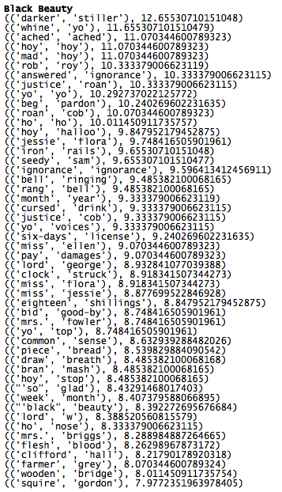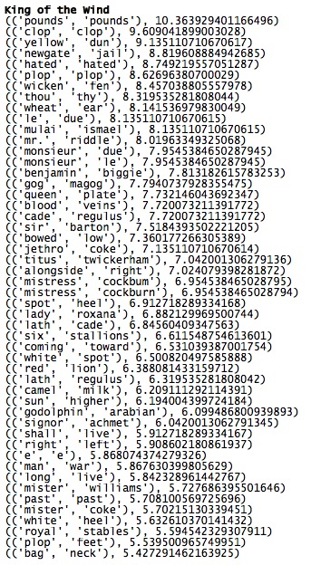

Figure Top 50 Bigrams using PMI by Corpus

The bigrams by PMI are quite different for each corpus. In fact, the language shows to be more expressive in *Black Beauty* than what was presented before. There is more information about the surroundings including sounds and what can be seen with “darker stiller” and “clock struck” and “draw breath”. There is more emotion conveyed as well with “ignorance ignorance” and “ached ached” which give more details of what it might have been like for Beauty going through life.

The bigrams by PMI show similar depth with PMI in *King of the Wind* using words like “bowed low”, “blood veins”, “white spot” and “sun higher”. There is mention of the white spot on Sham’s ear (called “wheat ear” showing descriptive text). However, using PMI, *Black Beauty* is more in line with *King of the Wind* providing a deeper meaning to the corpus.

## Top 50 Trigrams Using Pointwise Mutual Information (PMI) by Frequency

Because of this commonality between the two books. I wanted to look a step further and repeat PMI using trigrams. These were also done with a window size of five (5) and a frequency filter of three (3). enough variation in the results. The results by corpus are found in the following figure.

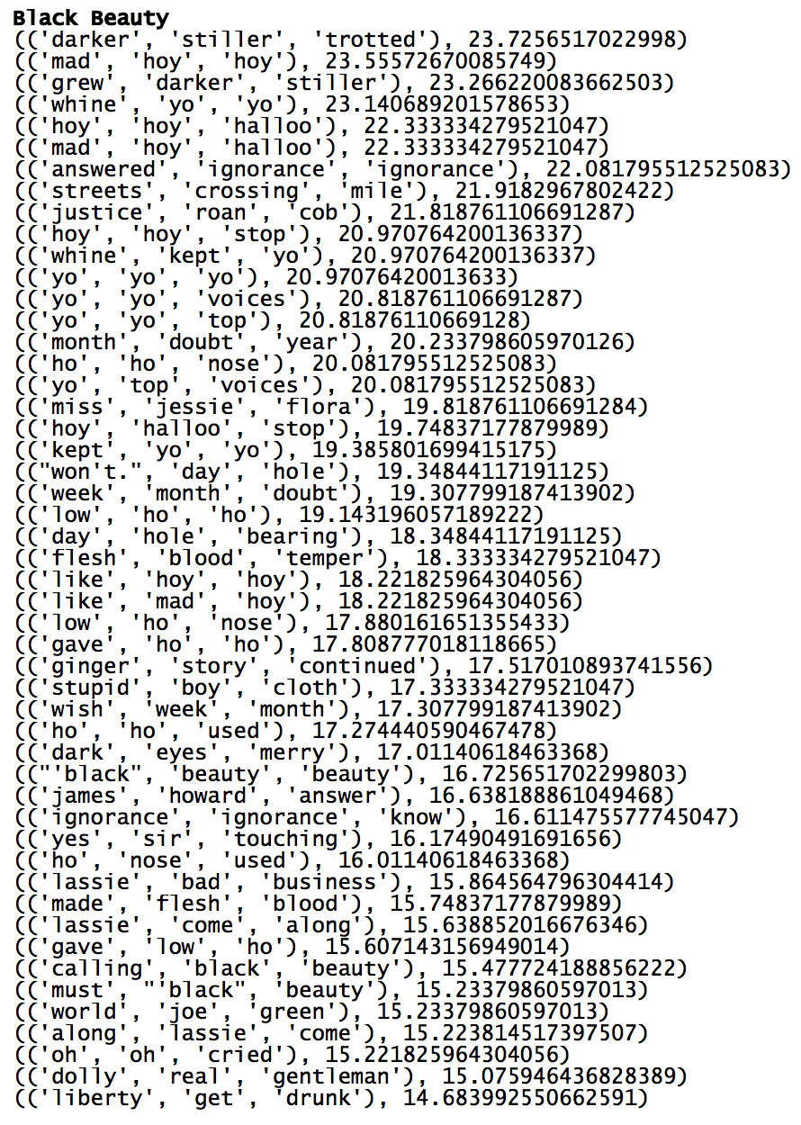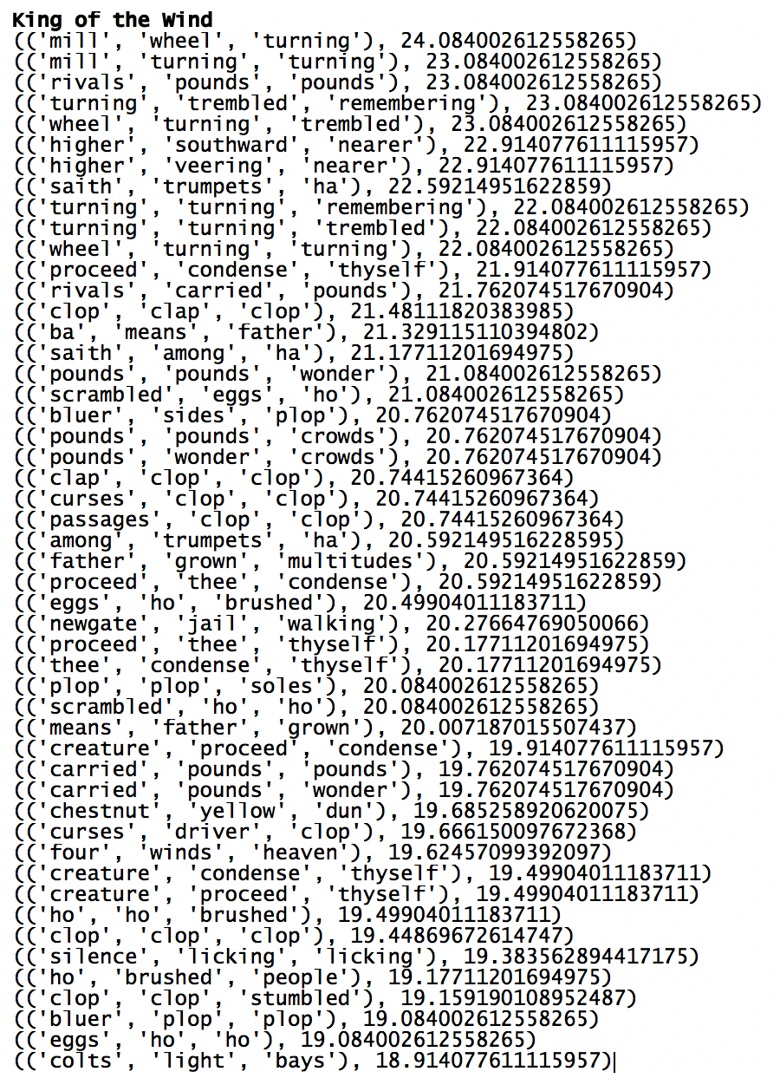

Figure Top 50 Trigrams using PMI by Corpus

Ironically, the text and type of writing style start to converge when looking at the trigrams using PMI. There is equal descriptive text and feeling as well as descriptions of the surroundings.

# Conclusion

As shown in the comments after each test, with limited data, the writing style of Sewell and Henry are quite different. Sewell writes more like the books of her day with more restraint and formality where Henry provides a more fluid and descriptive text with interesting descriptions of sounds and surroundings. However, this changes after further investigation and the authors write a in very similar way. Both provide descriptive text like “grew darker still” and “flesh blood temper” from *Black Beauty* and “turning trembled remembering” and “curses driver stop” from *King of the Wind*.

This was what I expected. Despite the fact that one book (*Black Beauty*) is written from the horse’s perspective and the other (*King of the Wind*) from the master/narrator position, both show the ability to capture the feelings of these horses as they examine their life and surroundings. This is even more interesting because the books were also written in different countries over 75 years apart.

# Additional Resources

<https://en.wikipedia.org/wiki/Anna_Sewell>

<https://en.wikipedia.org/wiki/Marguerite_Henry>